MANGAL MANDAP

**PAGE-1**

1. **Account Info-users**

|  |  |  |
| --- | --- | --- |
| **S.No** | **Field Name** | **Description / Logic** |
| 1 | Name | Text type only |
| 2 | Email | Check in DB Already Registered |
| 3 | Number | type only Number |
| 4 | Password | Create Strong Password |
| 5 | Profile For (Dropdown) | Self,Son,Daughter,Sister,Brother,Relative/friend,Other(Gender,) |

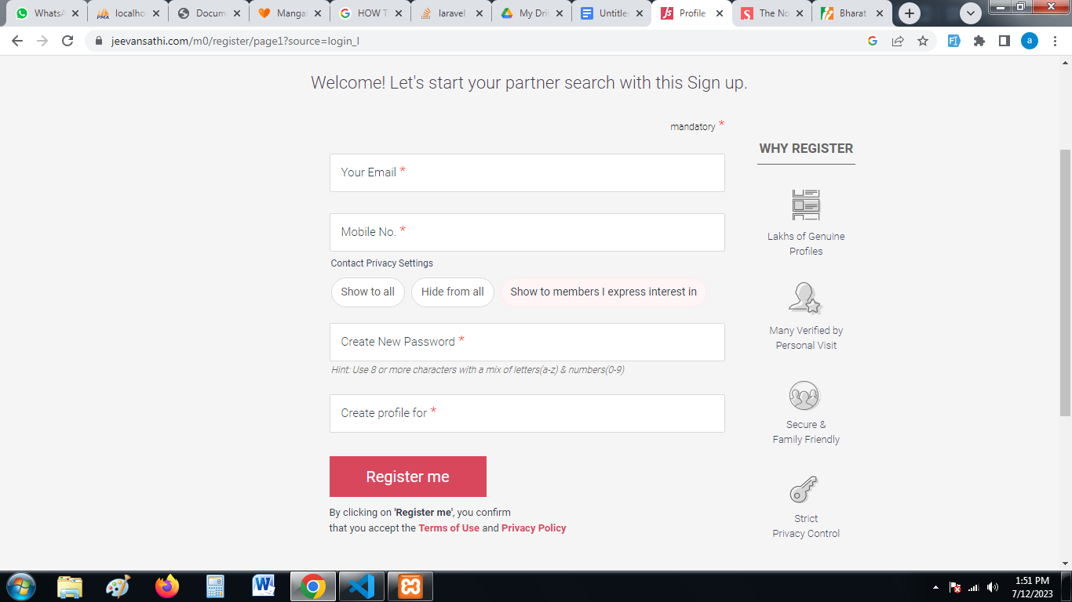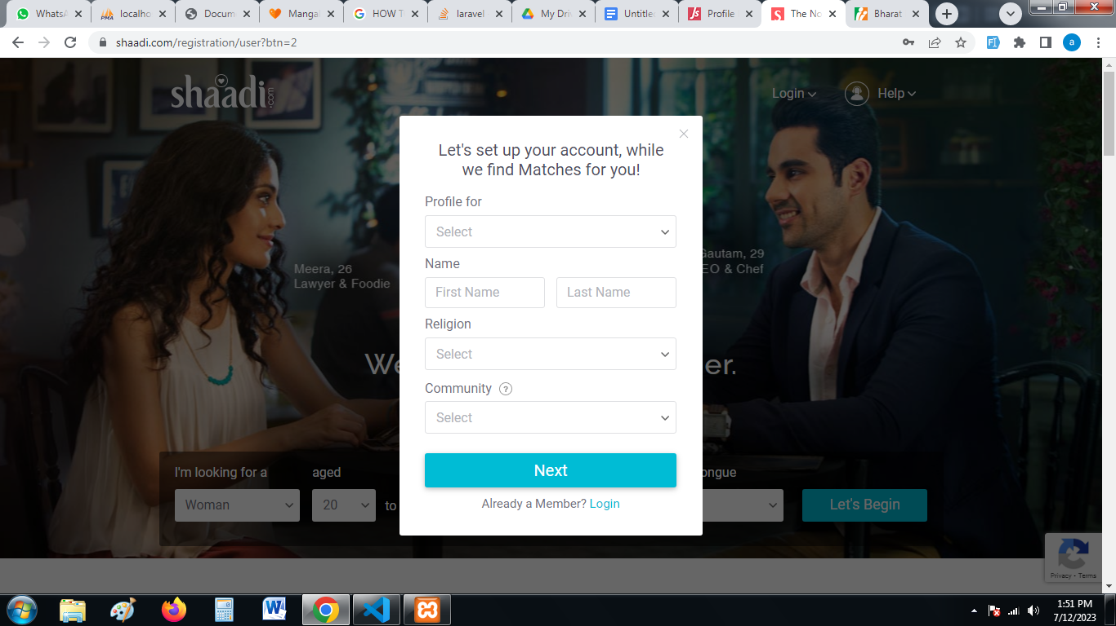

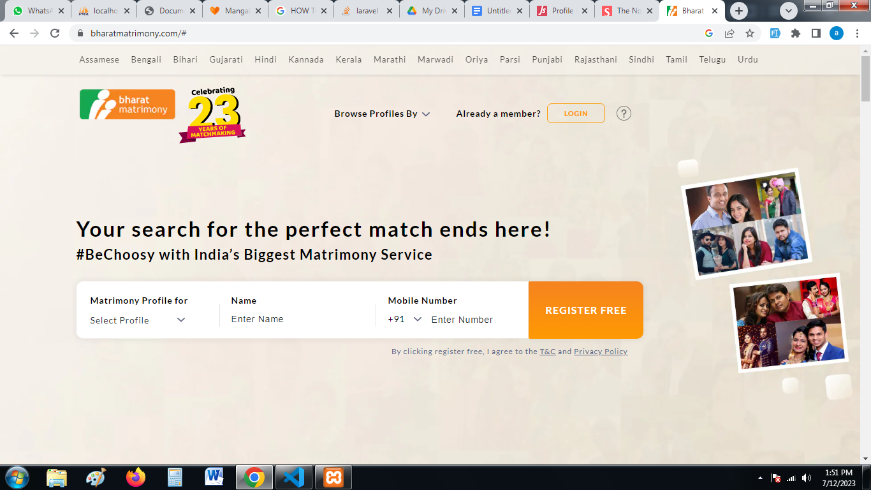

**PAGE-2**

1. **Basic Info**

|  |  |  |
| --- | --- | --- |
| **S.No** | **Field Name** | **Description / Logic** |
| 6 | Dob | Use Calendar. |
| 7 | Height (Dropdown) | Use an inch or centimeter. |
| 8 | Religion (Dropdown) | Hindu,Jain,Muslim,Sikh,Christian,Buddhist,Parsi,Bahai,Jewish. |
| 9 | Mother Tongue (Dropdown) | All indian mother tongues. |
| 10 | Caste (Dropdown) | All indian caste (Check box for caste no bar) in below caste. |
| 11 | Marital Status(Dropdown) | Never Married, Awaiting Divorce, Divorced, Widowed, Annulled. |

**PAGE-3**

1. **Horoscope Details**

|  |  |  |
| --- | --- | --- |
| **S.No** | **Field Name** | **Description / Logic** |
| 12 | Time of birth | Use a Time Calendar. |
| 13 | Manglik(Dropdown) | Manglik Dosh Yes or No |
| 14 | City of birth | Country->state->city |
| 15 | Rashi/Sun sign(Dropdown) | All rashi name |
| 16 | Horoscope match(Dropdown) | Profile show According to (Must, Not necessary, Doesn’t matter ) |
| 17 | Horoscope Privacy(Dropdown) | 1.Show to all, 2. Hide from all 3. Show only request accepted |

**Show only edit section**

|  |  |  |
| --- | --- | --- |
| 18 | Nakshatra | Reference from jeevansathi |

**PAGE-4**

1. **Carrier Details**

|  |  |  |
| --- | --- | --- |
| **S.No** | **Field Name** | **Description / Logic** |
| 19 | Country->State->City |  |
| 20 | Highest Degree | Course Name |
| 21 | Employed In | Private, Government, |
| 22 | Occupation |  |
| 23 | Annual Income |  |
| 24 | About you | Explain about you |

**Show only edit section**

|  |  |  |
| --- | --- | --- |
| 25 | School Name |  |
| 26 | College Name |  |
| 27 | Organization Name | Working Company name |
| 28 | Interested in settling abroad(Dropdown) | Yes or No |

**PAGE-5**

1. **Family Details**

|  |  |  |
| --- | --- | --- |
| **S.No** | **Field Name** | **Description / Logic** |
| 29 | Father's Occupation(Dropdown) | Business, Service-Private,Service-Govt.,Army/Armed Force,Civil Services, Retired, Not Employee, Expire |
| 30 | Mother's Occupation(Dropdown) | Housewife,Business, Service-Private,Service-Govt.,Army/Armed Force,Civil Services, Retired, Not Employee, Expire |
| 31 | Brother(Dropdown)->Married Brother | 1,2,3,4 |
| 32 | Sister(Dropdown)->Married Brother | 1,2,3,4 |
| 33 | Family living in | Country->State->City |
| 34 | Contact address(Text) |  |
| 35 | About My Family(Text Area) |  |

**Show only edit section**

|  |  |  |
| --- | --- | --- |
| 36 | Family Type(Check Box) | Joint,Nuclear |
| 37 | Family values(Check Box) | Traditional,Moderate,Liberal |
| 38 | Family Affluence(DropDown) | Lower,Middle,Upper,Rich,Class |
| 39 | Native Place(Text) |  |

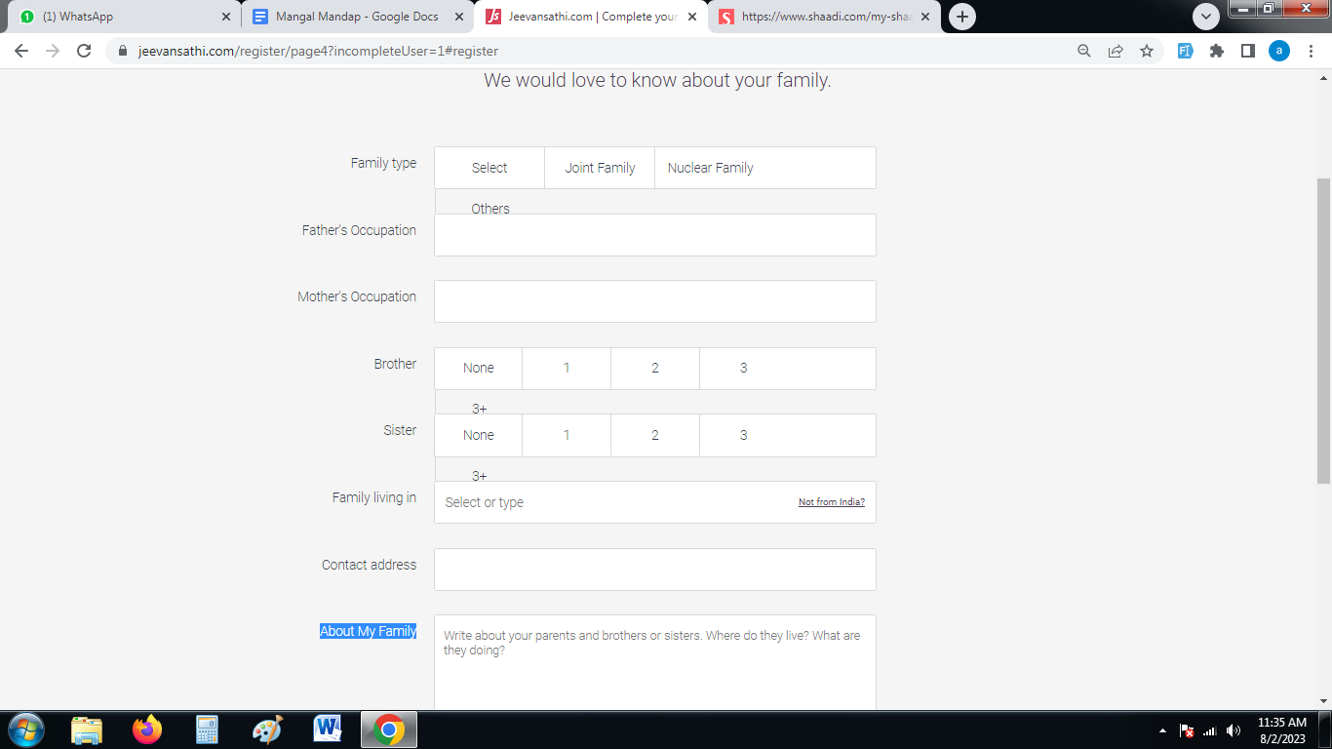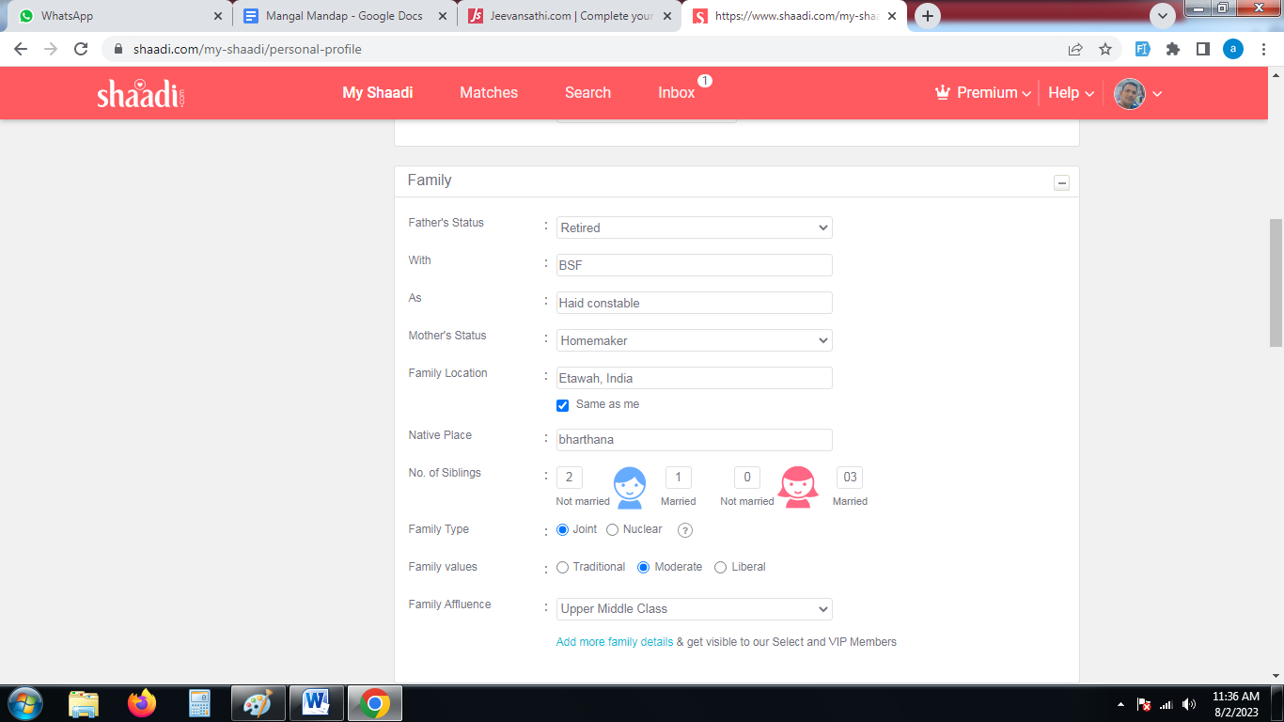

**PAGE-5**

1. **Lifestyle Details**

|  |  |  |
| --- | --- | --- |
| **S.No** | **Field Name** | **Description / Logic** |
| 40 | Dietary Habits(Dropdown) | Vegetarian, Non-Vegetarian, jain, Eggetarian |
| 41 | Drinking Habits(Dropdown) | Yes, No, Occasionally |
| 42 | Smoking Habits(Dropdown) | Yes, No, Occasionally |
| 43 | Challenged(Dropdown) | None, Physically-from birth,Physically-due accident, Mental-from birth, Mental- due to accident |

**Show only edit section**

|  |  |  |
| --- | --- | --- |
| 44 | Open to Pets?(Dropdown) | Yes, No |
| 45 | Own a House?(Dropdown) | Yes, No |
| 46 | Own a Car?(Dropdown) | Yes, No |
| 47 | Languages I Speak(Dropdown) | All-Regional, International-Main Language |
| 48 | HIV+?(Dropdown) | Yes, No |
| 49 | Thalassemia(Dropdown) | Major, Minor, No |

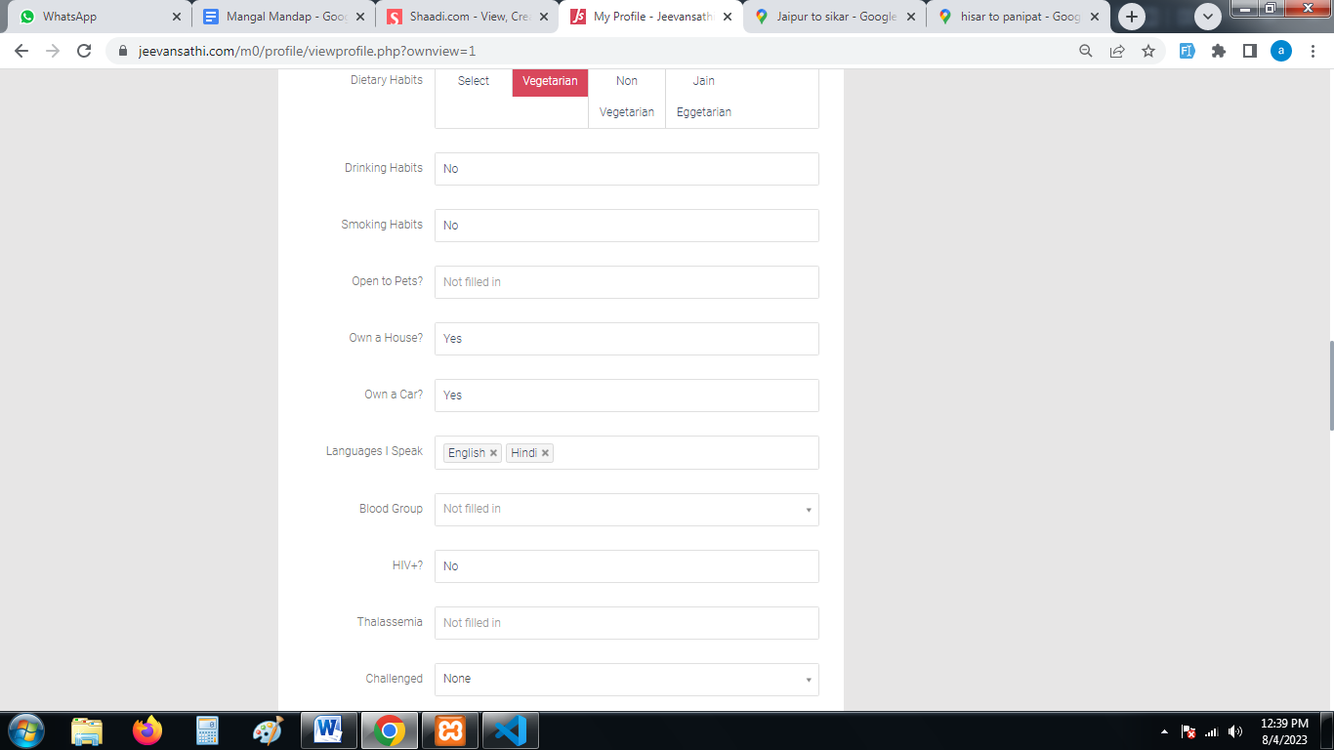

**PAGE-6**

1. **Your Likes ->Show only edit section**

|  |  |  |
| --- | --- | --- |
| **S.No** | **Field Name** | **Description / Logic** |
| 50 | Hobbies(Dropdown) | Ham radio,Collecting Stamps, Collecting Coins,Collecting antiques,Cooking,Film-making,Gardening / Landscaping,Art / Handicraft, Painting,Photography,Model building, Bird watching,Fishing,Taking care of pets,Playing musical instruments,Singing,Dancing,Acting,Astrology / Palmistry / Numerology,GraphologySolving Crosswords, Puzzles |
| 51 | Interests(Dropdown) | Listening to music,MoviesTravel / Sightseeing,Sports - Outdoor,Video / Computer games,Writing,Reading / Book clubs,Learning new languages,Theatre,Watching television,Sports - Indoor,Trekking / Adventure sports,Alternative healingYoga / Meditation,Health & FitnessVolunteering / Social ServicePolitics,Net surfing,Blogging |
| 52 | Favourite Music(Dropdown) | Classical – Hindustani,Classical - Western,Instrumental - Indian,Old film songs,Hip-Hop,Rap |
| 53 | Dress Style(Dropdown) | Trendy - in line with the latest fashion,,Classic Western - typically western formal wear,Designer - only leading brands will do,Casual - usually in jeans and T-shirts |
| 54 | Movies(Dropdown) | Classics,Web-series,Romantic,ComedyHorror,Sci-Fi & Fantasy,Action / Suspense,Non-commercial / Art,World cinema,DocumentariesDramaEpicsShort films |
| 55 | Sports(Dropdown) | Cricket,Jogging / WalkingCycling,Swimming / Water sports,Martial Arts,Yoga / Meditation,Hockey,Football,Volleyball,CarromBilliards / Snooker / Pool,Golf,Weight training,Chess,Card games,Bowling,Scrabble,Aerobics,Basketball,Table-tennisRugby,Adventure sports,Badminton,Tennis,Squash,Baseball |
| 56 | Favourite Book(Text box) |  |
| 57 | Favourite Read(Text box) |  |
| 58 | TV Shows(Text box) |  |
| 59 | Cuisine(Text box) |  |
| 60 | Food I Cook(Text box) |  |
| 61 | Vacation Destination(Text box) |  |
| 62 | Favourite Movies(Text box) |  |

**PAGE-7**

1. **Contact Details**

| **S.No** | **Field Name** | **Description / Logic** |
| --- | --- | --- |
| 63 | Email id |  |
| 64 | Alternate Email Id |  |
| 65 | Mobile No. |  |
| 66 | Name of owner(Text) |  |
| 67 | Relationship(Dropdown) | Groom,Parent,relative,Sibling |
| 68 | Alternate No. |  |
| 69 | Landline No. |  |
| 70 | Name of owner(Text) |  |
| 71 | Relationship(Dropdown) | Groom,Parent,relative,Sibling |
| 72 | Suitable Time to Call(Time) |  |
| 73 | Contact Address(Text) |  |
| 75 | Pin code |  |
|  | Parent's Address(Text) |  |
|  | Pin code |  |